Pre-class Assignment

Aspect-Oriented Programming

## Getting Started with Aspect-Oriented Programming

Watch: <https://app.pluralsight.com/library/courses/aspect-oriented-programming-spring-aspectj/table-of-contents>

* **ALL** of “Why Aspect-oriented Programming (AOP)?”
* The **Introduction** section of “Your First Aspect”

## What to learn

* What is Aspect-Oriented Programming?
* What are the benefits of AOP?
* What concerns does AOP address?
* What is an aspect?
* What are the parts of an aspect?

## Preparing to use Aspect-Oriented Programming

*AOP can be implemented in a variety of ways. We will be using AspectJ. It is an extension of the Java programming language.*

1. Install/verify **IntelliJ Ultimate Edition**

*The community Version of Intelli J does* ***NOT***  *support the AspectJ compiler. You will need to install the IntelliJ Ultimate Edition to use it.* ***You can have multiple editions of IntelliJ installed at the same time****, so you will not need to uninstall or overwrite your current installation.*

1. Make sure you have an @byu.edu e-mail alias: <https://alias.byu.edu/>
2. **Apply for the Student IntelliJ Licenses** here : <https://www.jetbrains.com/student/>
   1. After applying you will receive an e-mail from JetBrains, You will need to go to it and **confirm your e-mail**
   2. After confirming your e-mail you will be redirected to a page where you can sign-in to an existing IntelliJ account or create a new IntelliJ account
      1. **You will need an IntelliJ account** to access the Ultimate edition, so make sure to register for an account if you don’t already have one.
   3. After logging in/registering you will be brought to a page showing your education license.
   4. Click Download -> **Click IntelliJ IDEA Ultimate. Download and install.**

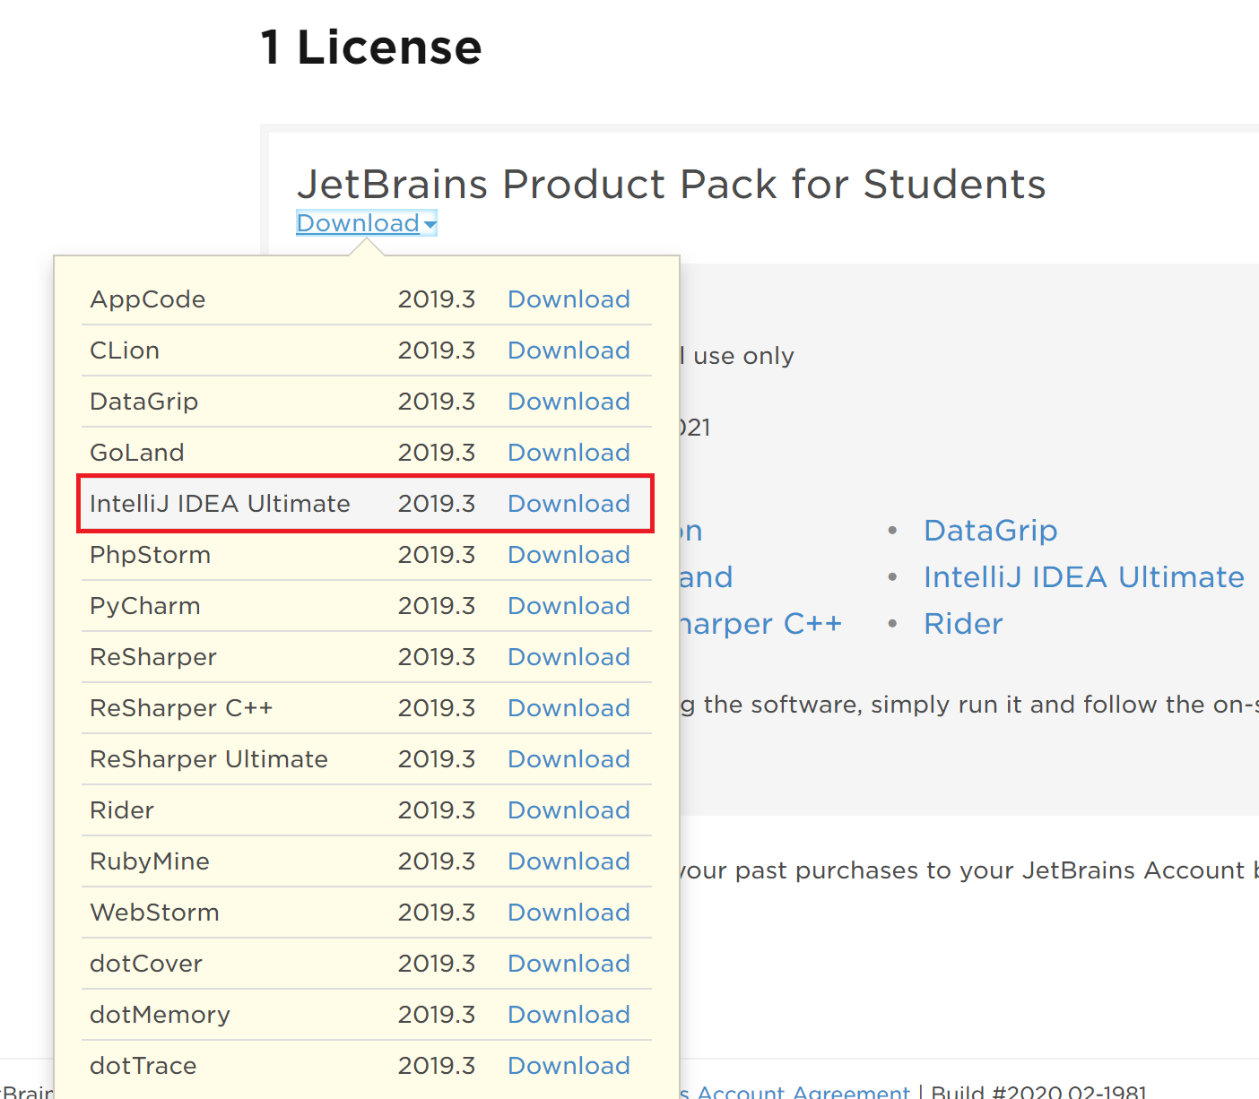

## 

## Using Aspect-Oriented Programming with AspectJ

*AspectJ has its own compiler, ajc. It is an enhanced version of javac. It will compile normal java code as well as aspect code.*

**Read the first Page of this blog :** [*https://blog.jayway.com/2015/09/03/aspectj-and-aop-the-black-magic-of-programming/*](https://blog.jayway.com/2015/09/03/aspectj-and-aop-the-black-magic-of-programming/)

1. Download and Install AspectJ
   1. **Download the latest Stable jar release** of AspectJ from the following link : <https://www.eclipse.org/aspectj/downloads.php>
   2. **Run the AspectJ jar** and run through the installation wizard

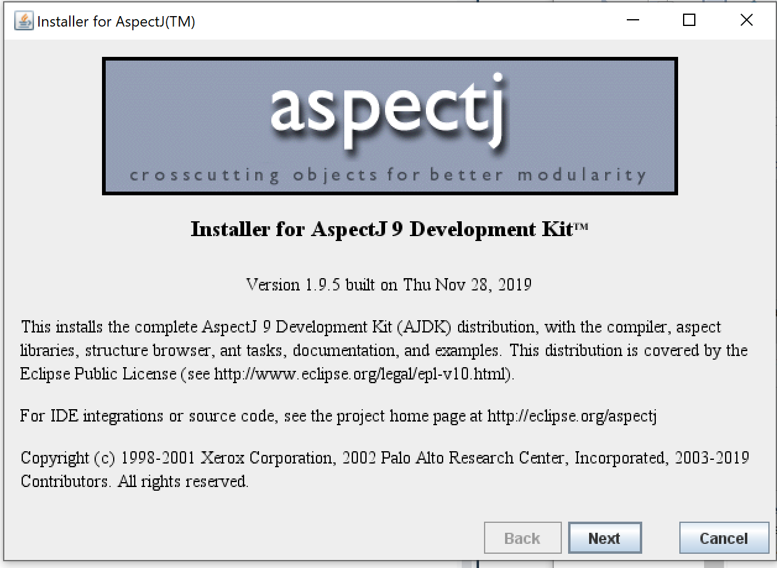

**Note:** Make sure to take note of where you are installing AspectJ, you will need to access this folder later

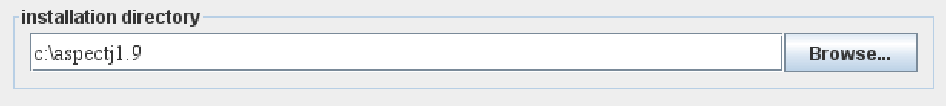

1. SetUp AspectJ on an IntelliJ Project
   1. Follow the guide in the link below to **create an IntelliJ project that can use AspectJ**

[https://docs.google.com/document/d/1QPVaN2LyihU1Ri1PlyPFPnGoUhGG62vLYOLMuYrUQDo/edit?usp=sharing](https://drive.google.com/open?id=1BnNSZ15zQUweNuswG2FQutKXKhUmX5M1qJxygSuLg70)

## Finishing Up

If you have an IntelliJ project that can run the example aspect, then you are finished and ready for the lab.